**Combat**

**Marksmanship**

**Coach (CMC)**

**Course**

**Quantico, VA**

1. COURSE PURPOSE. To train students in Combat Marksmanship Coaching techniques, procedures, and theory, for service within the major supporting commands and supporting establishments.

1. COURSE SCOPE. This course provides the knowledge, skills, and attitudes required for a Marine to succeed as a Combat Marksmanship Coach (CMC); ADMOS 0933.

1. COURSE PREREQUISITES.

* 1. Minimum of one year TIS.
  2. Minimum of one year remaining on contract upon graduation.
  3. Current Sharpshooter or higher qualification with the service rifle. d. Any MOS.
  4. Be in full duty status.
  5. Meets current height and weight standards.
  6. 20/20 corrected vision.
  7. Completed Command Screening Checklist.

1. REPORTING IN.

* 1. Non-local students will report by 2359 on the course report date for arrival orders endorsement and area orientation. Highly recommend inbound flights arrive early afternoon to facilitate check-in and proper rest. Please check-in with the WTBN OOD (WTBN HQ, Bldg #27211) in appropriate civilian attire. Physical address to WTBN is 27211 Garand Road, Quantico, VA, 22134. Student MCC K49, RUC 30903.

* 1. Local students will report in MARPAT’s directly to the classroom on the course convene date. Non-funded original orders are required.

* 1. All students must be seated in the Battalion Classroom (Bldg #27218) by 0800 on the course convene date with original orders, signed command screening checklist, copy of BTR, copy of flight itinerary, note taking gear, hydration container, and this welcome aboard package. Uniform throughout the course and graduation is Woodland MARPAT’s with sleeves down.

1. LODGING & MESSING.

* 1. Lodging: Government no cost (barracks) lodging is not available or provided. Arrange lodging first at Liversedge Hall (Quantico Military Temp Lodging Facility); a non-availability number is required to justify other lodging and to settle Defense Travel System (DTS) travel claim. If there is no availability, use DTS for on/off base hotel; MCB Quantico on base commercial hotel is Crossroads Inn. Students will require daily unit provided transportation to/from lodging and the schoolhouse; i.e. rental car or POV.

* 1. Messing: Government messing is available. The WTBN Dining Facility (Bldg #27269, Malachowski Hall) is centrally located within the WTBN area.

Students must pay the standard meal rate and my use credit or debit for payment. Only local students may use their unit issued meal card; those on non-funded TAD orders. Weapons are not allowed in the dining facility. Uniform of the day or proper civilian attire required. No PT gear allowed!

**WEEKDAY HOURS / COST WEEKEND & HOLIDAY HOURS / COST**

Breakfast 0530-0730 / $3.45 Brunch 1000-1130 / $6.25 Lunch 1100-1300 / $5.60 Supper 1600-1700 / $7.65 Dinner 1630-1730 / $4.85

1. WTBN MARINE CORPS EXCHANGE (MCX). Limited exchange services and items are available at the WTBN MCX (Bldg #27271-T). There is an ATM machine located next to the MCX. Basic 7-day store items (food/drink, hygiene, rank insignia, etc.) are available. Weapons are not allowed in MCX facilities. Uniform of the day or proper civilian attire required. No PT gear allowed!

**WTBN MCX HOURS**

Monday thru Friday 0600–1800

Saturday & Sunday 0900-1400

1. WTBN GYM. The WTBN gym (Bldg #27200) is one end/side of a converted squad bay located across the street from the WTBN MCX. Standard free weights and various weight/cardio machines are available. Students are expected to cleanup and put equipment back after use. No equipment will be removed from the gym! An outdoor basketball court is available behind the WTBN BEQ.

1. LEAVE/SPECIAL LIBERTY. Leave and special liberty will not be granted. Weekend Liberty Limits are within 300 miles of Quantico; out of bounds will not be authorized. If an emergency situation or personal problem develops, you will inform an instructor immediately. The Schoolhouse SNCOIC will assist students in contacting their parent command in case of an emergency.
2. TRANSPORTATION. Before the last week of training, students will ensure all travel arrangements are made and verified for the return trip to their parent command. This includes transportation from WTBN to the airport; WTBN does not provide transportation to/from airports. Graduation will commence NLT 1100, plan all flights accordingly and allow one hour for travel to the Airport.
3. POV's/RENTAL VEHICLES. Parking for all students is permitted **ONLY** in the barracks parking lot or in the **CENTER** of the main WTBN parking lot. Do not park in any other WTBN area!

1. CHAIN OF COMMAND. The Chain of Command provides a means to account for all students and assist with any issue which may arise. Students will utilize the schoolhouse Chain of Command, students are never authorized to initiate liaison with any WTBN Staff section without permission from an instructor.

* 1. Students will use the following Chain of Command:

* + 1. Primary Instructor.
    2. Chief Instructor.
    3. Schoolhouse SNCOIC.
    4. Commanding Officer, Marksmanship Training Company.

* 1. Request Mast. Every Marine has the right to request mast. Students may request mast to the following:

* + 1. Commanding Officer, Marksmanship Training Company.
    2. Commanding Officer, WTBN.

* 1. WTBN Sergeant Major. Enlisted Marines desiring to speak with the Battalion Sergeant Major will do so by going through a modified chain of command:

* + 1. Primary Instructor.
    2. Chief Instructor.
    3. Schoolhouse SNCOIC.
    4. Battalion Sergeant Major.

1. TELEPHONE INFORMATION. Telephone calls of a professional or official nature will be taken by the Instructor Staff and relayed to the student.

Emergency calls will be handled as required. Students will not make or receive personal calls via government phones. Pertinent phone numbers are:

* 1. Schoolhouse: (703) 784-5527 DSN 278-5527

* 1. CMC Course Seats: (703) 784-6682 DSN 278-6682

* 1. WTBN OOD/CP: (703) 784-5341 DSN 278-5341 WTBN OOD Cell Phone: (703) 675-2273

1. TRAINING AND ACADEMICS.

* 1. The training schedule for each class gives the time, location, class or activity, and instructor for all training events. Students are responsible to be at the appointed place, at the appointed time, with the required equipment. A copy of the schedule will be posted in the classroom and all students will be provided with a copy during the course in-brief. Updates and changes will be passed by the Course Chief as needed. Failure to follow the training schedule may result in being dropped from the course; based on the situation punitive action may be taken. Absence from training must be approved by the Schoolhouse SNCOIC prior to being absent. Students can miss no more than four hours of instruction during the course.

* 1. Marines who need to go to sick call will inform their Primary Instructor. Any illness or injury to a student, regardless of severity, will be reported to the Instructor Staff immediately.

* 1. Your primary goal while attending the course is to show mastery of the knowledge and skills taught throughout the program of instruction. Counseling is conducted if student academic performance is not up to standard. Students who need additional instruction or help will inform their Primary Instructor;

ASK AND YOU WILL RECEIVE. One retest is allowed for each testable event. Should a student fail to maintain an 80% average upon being retested, they will be dropped from the course. In addition, failure of three separate graded events will result in being dropped upon failure of the third event.

1. UNIFORMS/EQUIPMENT.

* 1. Serviceable MARPAT utility uniforms will always be worn. During winter months beanies are only allowed to be worn while down range. Heavy fleece may be worn if under the utility uniform or Gortex.

* 1. Students must bring all required gear, as well as a copy of their **ORIGINAL ORDERS, COMMAND SCREENING CHECKLIST, and CURRENT BTR**. Failure to report with required gear and documents are grounds for dismissal from the course. Failure to meet the course prerequisites without a prior approved/coordinated waiver will result in Marines being returned to the parent command upon check-in.

* 1. Minimum required gear:

* + 1. 2 pair of MARPAT utilities w/eight point cover.
    2. 6 skivvie shirts.
    3. 6 skivvie shorts.
    4. 2 pair of boots.
    5. Gortex top and bottom.
    6. USMC approved Flak jacket.
    7. USMC approved Kevlar helmet.
    8. Cartridge belt.
    9. 3 rifle magazine pouches.
    10. 9mm service pistol holster system; SERPA drop.
    11. 9mm pistol magazine pouch.
    12. Gloves.
    13. Camelback or canteen.
    14. Warming layers; seasonal as needed.
    15. Weapons cleaning gear.
    16. Eye and hearing protection.
    17. Ear protection.
    18. Note taking gear.
    19. Flashlight.
    20. Personal hygiene items/towel/shower shoes; as needed.
    21. Appropriate civilian attire.
    22. Military ID card.
    23. Dog tags.
    24. Original orders.
    25. Signe command screening checklist.
    26. Current BTR; shows current rifle score.

1. CONDUCT AND BEHAVIOR. Insubordination, disrespect, belligerence, or demonstrations of contempt **WILL NOT** be tolerated and will result in being dropped from the course.

* 1. Grooming standards will be strictly adhered to by all students.

* 1. Appropriate civilian attire is required at all times.

* 1. Smoking is authorized in designated areas only.

* 1. Field day of the classroom area/head will be conducted at the end of each training day.

* 1. Always use proper classroom etiquette. Mature behavior is required during classes, ranges, and field exercises. While the exchange of information and questions are encouraged, they must be done in a proper and respectful manner. Students must always remain alert and attentive.

* 1. Abuse of alcohol or drugs **WILL NOT** be tolerated. Students under the influence of drugs or alcohol during the course **WILL IMMEDIATELY** be dropped from the course and sent back to their parent command. Appropriate disciplinary action can be expected.

* 1. Any of the following incidents will be considered grounds to be dropped from the course and/or disciplinary action:

* + 1. Any violation of the UCMJ and/or Civil Law.
    2. Any safety violation.
    3. Disrespect to an instructor/WTBn Staff.
    4. Any unfavorable incidents involving WTBn personnel.
    5. Any involvement with Military Police/Civil Authorities.
    6. Alcohol/drug related incidents.
    7. Unauthorized possession of firearms or ammunition.
    8. Late for class or training/missing over 4 hours of instruction.
    9. Failure to follow instructions.

1. WTBN WEBSITE. [https://www.trngcmd.marines.mil/Units/Northeast/WeaponsTraining-Battalion/](https://www.trngcmd.marines.mil/Units/Northeast/Weapons-Training-Battalion/)

1. DRIVING DIRECTIONS (POINTS NORTH OR SOUTH OF MCB QUANTICO).

|  |  |
| --- | --- |
|  |  |
| 1 | I-95 South or I-95 North |
| 2 | Take exit 148 toward Marine Corps Base Quantico |
| 3 | I-95S turn right or I-95N turn left onto Russell Rd, go 2 miles to gate |
| 4 | Proceed through gate on Russell Road (becomes MCB-2/MCB-4) to WTBN |
| 5 | Turn right on Walsh Road into WTBN area (red WTBN sign) |
| 6 | At stop sign turn right on Garand Road then immediate right into parking lot. |
| 7 | WTBn OOD/Command Post (Bldg #27211) is on the end of the parking lot. **OOD Phone #: (703) 784-5341.**  **Physical Address: 27211 Garand Rd, Quantico, VA 22134** |

**STEP DIRECTIONS**

1. WEAPONS TRAINING BATTALION (WTBN) MAPS.

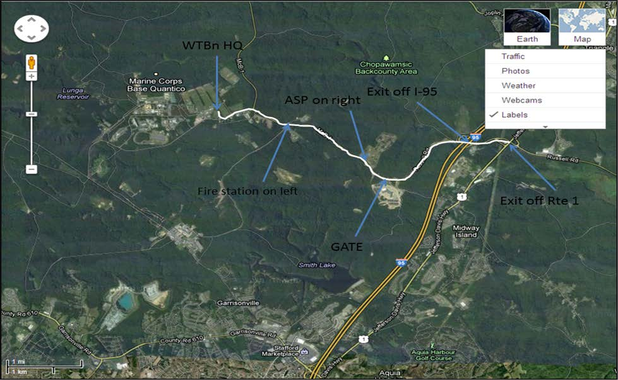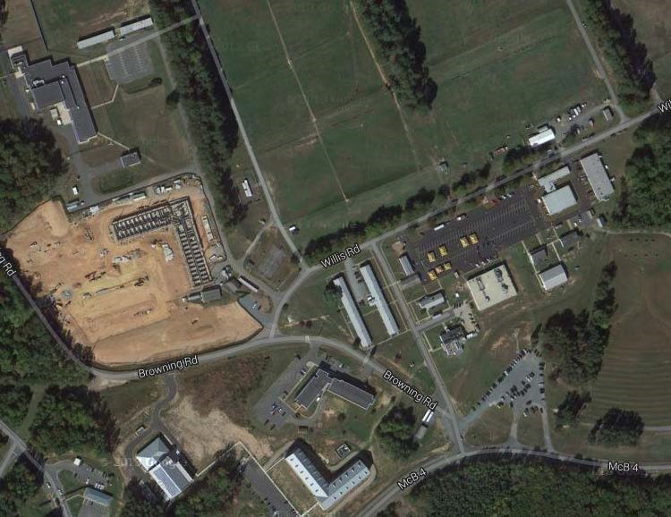

PWS/Armory

WTBn BEQ

Barracks/Parking

)

(

Academics

Basketball

Court

Bn Classroom CMC/CMT

Gym

Main

Parking Lot

Dining

Facility

MCX

(

Exchange

)

WTBn CP

)

(

OOD

AMTC

CMC/CMT

Snipers

MOES

MTC

Teams

ATM

|  |
| --- |
| **For Official Use Only - Privacy Sensitive**  Privacy Act Statement- This information is collected under the Privacy Act of 1974 (5 USC 552a) that governs the distribution and/or sharing of information from this file. Disclosure of this information is mandatory in accordance with SECNAVINST 5211.5E and MCO 3574.2K |

PURPOSE. To assist parent commands with the selection and screening process for Marines attending the Combat Marksmanship Coach (CMC) Course.

WAIVERS. Prerequisite waivers will be granted on a case-by-case basis. Requests will include strong justification and must be signed by Company CO. Please scan and send via email to Mr. Bob Bayer, C476 Sponsor, S-3 Operations, WTBN Quantico, (703) 784-6682 or DSN 278-6682, robert.w.bayer@usmc.mil. Note, waivers should be sent at least two weeks prior to course convening.

ACTION. **Students will report with one completed copy of this checklist.** Students who report not meeting the pre-req’s or without a completed command screening checklist will be disenrolled and returned to their parent command.

NAME: RANK: ___________

(Last, First, MI)

EDIPI: UNIT: _________________________________

|  |  |  |
| --- | --- | --- |
| **PREREQUISITE** | **REMARKS** | **QUALIFIED** |
| **PFC – GYSGT (ANY MOS)** | Course is designed for PFC through  GySgt who will perform duties as a  Combat Marksmanship Coach (MOS 0933). | Yes */* No |
| **MINIMUM OF 1 YEAR TIS** | Ensures sufficient time to observe  maturity and sustained performance. | Yes */* No |
| **FULL DUTY - 20/20 CORRECTED VISION** | Medically and physically qualified. Minimum of 20/20 corrected vision. | Yes */* No |
| **MINIMUM OBLIGATED SERVICE**  **EAS:** | Active Duty minimum of one year remaining on contract upon graduation. SMCR two years or sign SWAT. IRR two years remaining. | Yes */* No |
| **RIFLE SCORE: _______**    **DATE: _______________** | Current Sharpshooter or higher qualification with the service rifle; non-waiverable. Copy of BTR must be attached. | Yes */* No |
| **HEIGHT: _____ Body Fat: _____**  **WEIGHT: ___** | Meets current height and weight standards. | Yes */* No |

**Company Commander/First Sergeant/Company Gunnery Sergeant:**

Print: __________________________________________ Sign: ______________________

Date: Phone #: ___

**S-3 Representative: Ops Officer/A-Ops O/Ops Chief/A-Ops Chief/Schools NCO**

Print: __________________________________________ Sign: ______________________

Date: Phone #: ___